# Repair System Report

## L201826630107 Takura Mukaro

User home page

For user authentication I decided to make two different pages

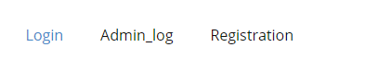

The above picture is a menu into the program

On the client side we have a form to which allows a user to enter their credentials and posts them

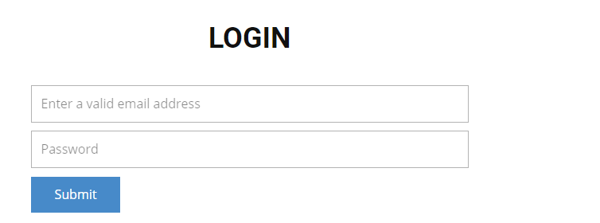

Admin login

This is where the workers login

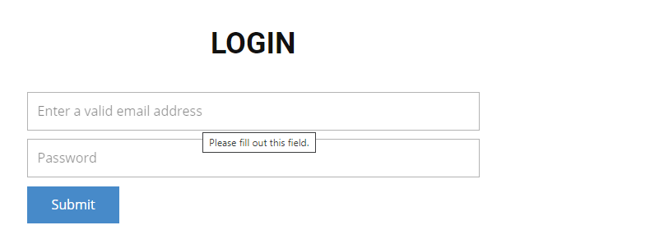

Redirect Pages

Having submitted one of the above forms I created a redirect page for each one of these two pages

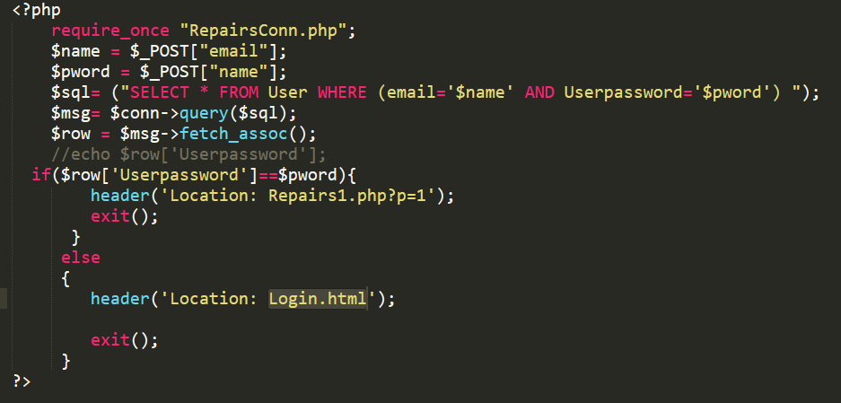

As one can see The program connects to the database uses the $_POST array to get the user credentials and matches them with the ones stored in the database and if not they match up the user will be redirected to Repairs.php which is the user account and if not they are redirected back to the login page

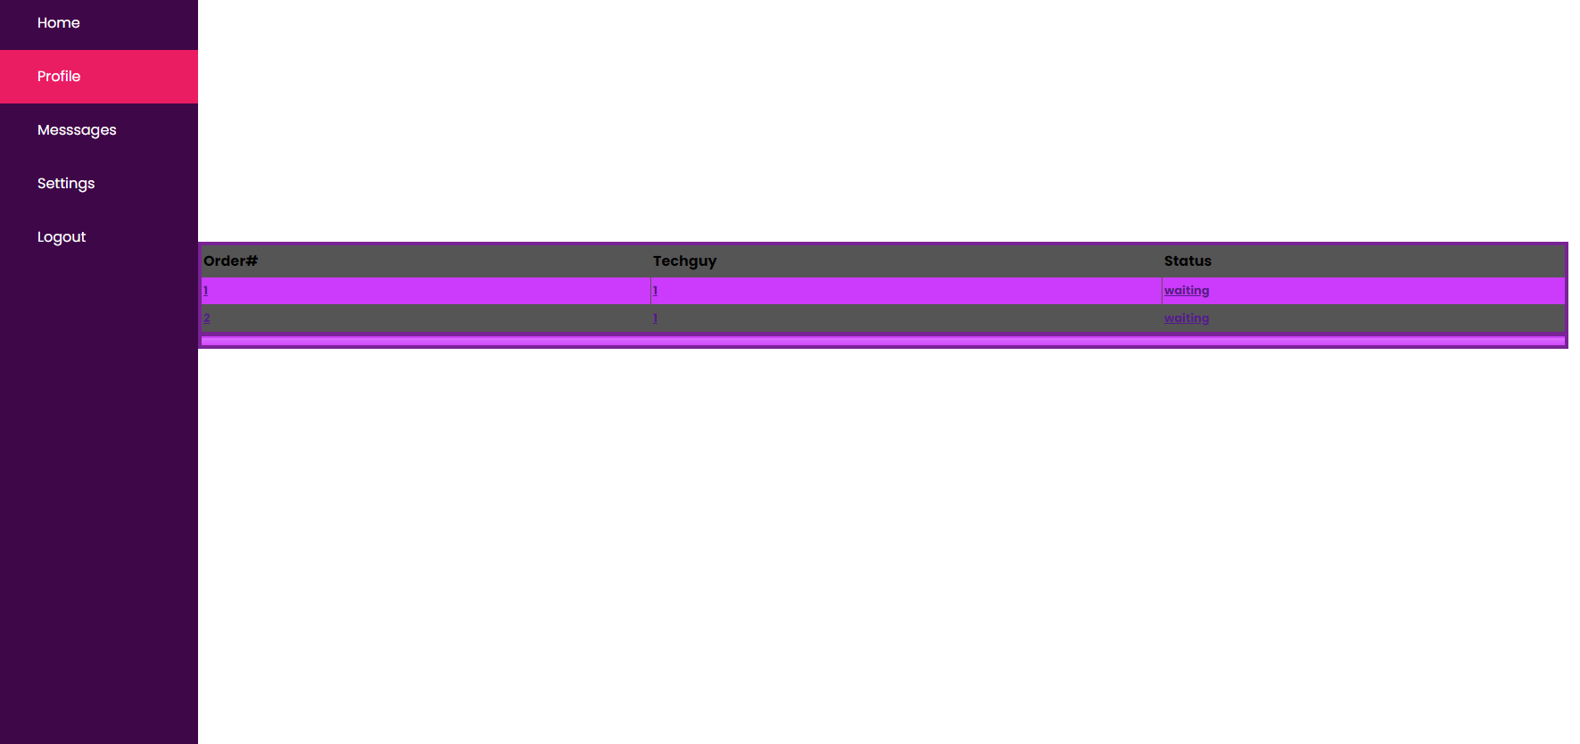

After login you go into the user account which is this.

It has he ability to show the user their ordersin a table which also has the id of the tech guy and we like to call them ,worker working on their particular device

On the side we have a navigation bar for the user to scroll through his account and for him also to log out

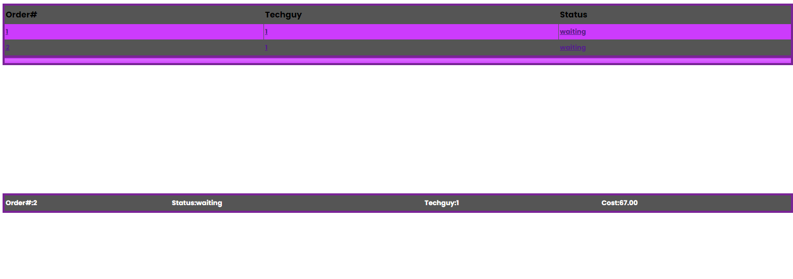

Upon clicking on one of the orders a new table appears giving the user a more in-depth look into that order’s status and the cost that has been charged by the technician

Worker Side login

This one is quite similar to the User login they get redirected to their own account

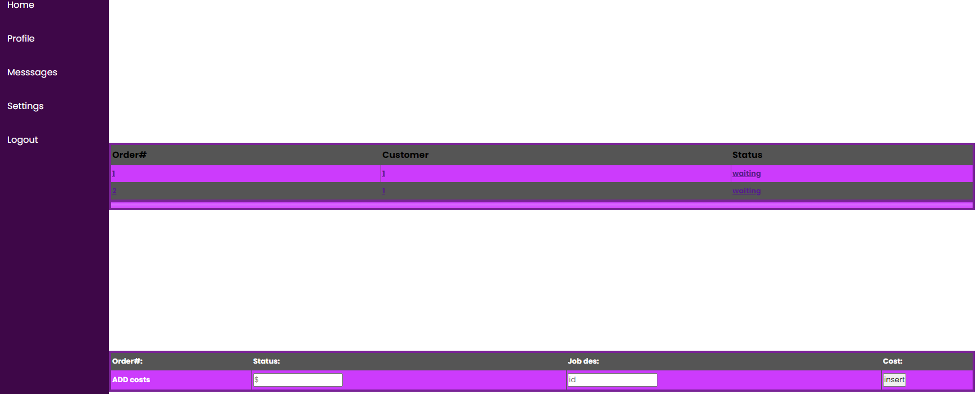

It quite similar to the user orders page but it allows the worker to input the cost of repairs so that the user knows how much they have to pay on their side.